Recipe Blog

Submitted By:

Rhea Gracy – 2460430 email: [rhea.gracy@btech.christuniversity.in](mailto:rhea.gracy@btech.christuniversity.in)

Jessica Nalini Paully – 2460377 email: jessica.nalini@btech.christuniversity.in

Angela Elizabeth Domingo – 2462033 email: angela.elizabeth@btech.christuniversity.in

**Course**: Front End UI/UX Development

**Instructor Name**: Dhiraj Alate

**Institution:** Christ University Kengeri

**Date of Submission**: 12-08-2025.

# Abstract

This project focuses on designing and developing a responsive recipe blog using HTML and CSS. The main goal was to create an attractive, easy-to-use platform where users can explore, read, and enjoy cooking recipes in an organized format. The website features a clean UI, mobile-friendly design, and visually appealing recipe cards. Key technologies used were HTML5 for semantic structure and CSS3 for styling and layout. The final output is a functional, responsive, and user-centric recipe blog suitable for food enthusiasts.

# Objectives

• Design a visually engaging and user-friendly recipe blog interface

• Develop a fully responsive layout using HTML5 and CSS3

• Organize content using semantic HTML tags

• Apply CSS styling for branding, readability, and responsiveness

• Ensure accessibility for desktop, tablet, and mobile devices

# Scope of the Project

The project is focused on front-end design and implementation using pure HTML and CSS. It does not include JavaScript-based interactivity or server-side integration. The design is optimized for multiple screen sizes, ensuring consistent presentation on desktop, tablet, and mobile devices.

# Tools & Technologies Used

|  |  |
| --- | --- |
| Tool/Technology | Purpose |
| HTML5 | Markup and content structure |
| CSS3 | Styling and layout management |
| VS Code | Code editor |
| Chrome DevTools | Testing and debugging |

# HTML Structure Overview

• Semantic tags: <header>, <nav>, <main>, <section>, <footer>

• Sections: Home, Recipes, About, Contact

• Navigation menu with <ul> and anchor links

# CSS Styling Strategy

• External CSS file (style.css)

• Flexbox and Grid for layout

• Media Queries for responsiveness

• CSS Variables for theme customization

• Hover effects and transitions

• Mobile-first design

# Key Features

|  |  |
| --- | --- |
| Feature | Description |
| Responsive Design | Adapts to all screen sizes |
| Smooth Navigation | Fixed nav with anchor links |
| Recipe Cards | Grid/Flex layout with hover effects |
| Contact Form (non-functional) | Layout for user input |
| Accessible Fonts & Colors | Readable, high contrast text |

# Challenges Faced & Solutions

|  |  |
| --- | --- |
| Challenge | Solution |
| Overlapping elements on small screens | Used media queries to stack elements |
| Alignment issues with floats | Shifted to Flexbox and Grid |
| Font scaling problems | Used relative units (em/rem) |

# Outcome

• Created a responsive recipe blog layout with HTML and CSS

• Achieved a clean and consistent design across devices

• Learned about responsive UI, accessibility, and semantic HTML

# Future Enhancements

• Add JavaScript for interactivity

• Integrate backend for recipe management

• Add animations and transitions

• Implement search and filter features

# Sample Code

HTML Example: here are few parts of the code that play a key role in formatting our recipe blog 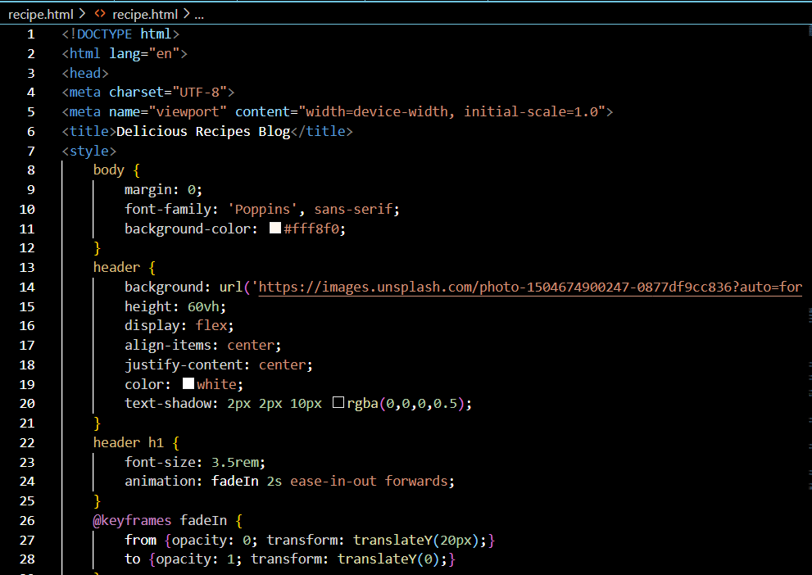

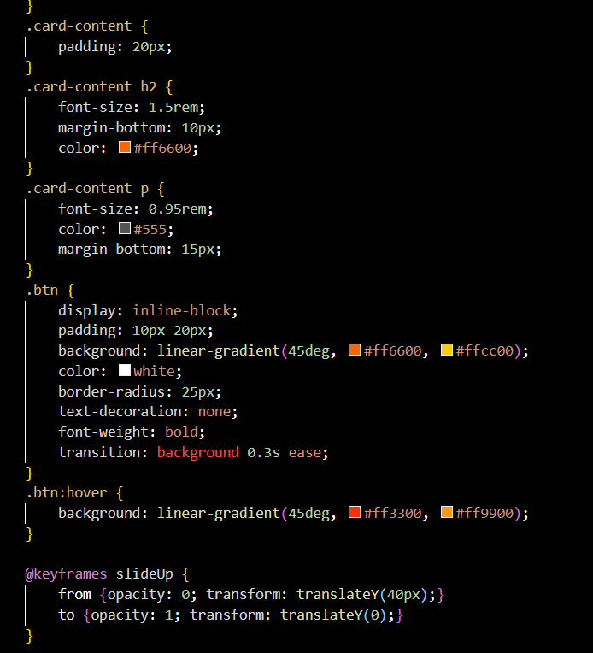

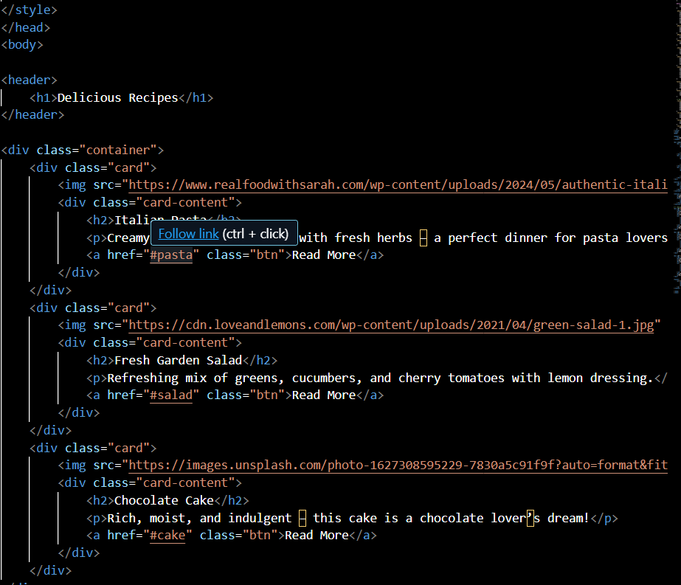

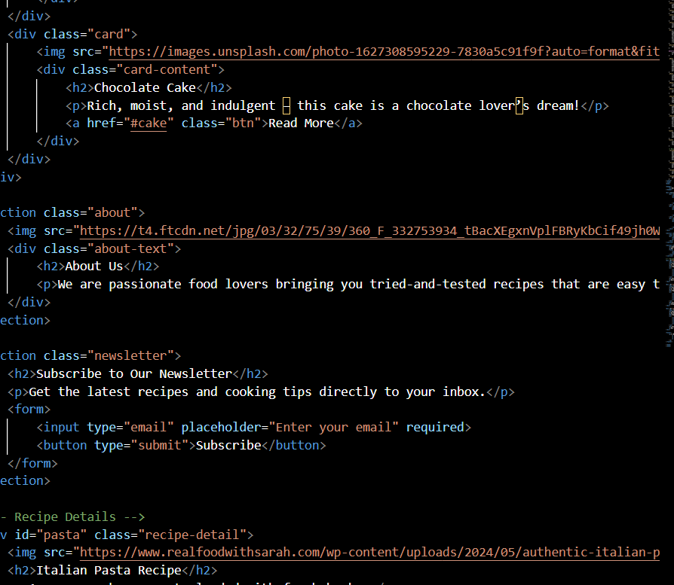

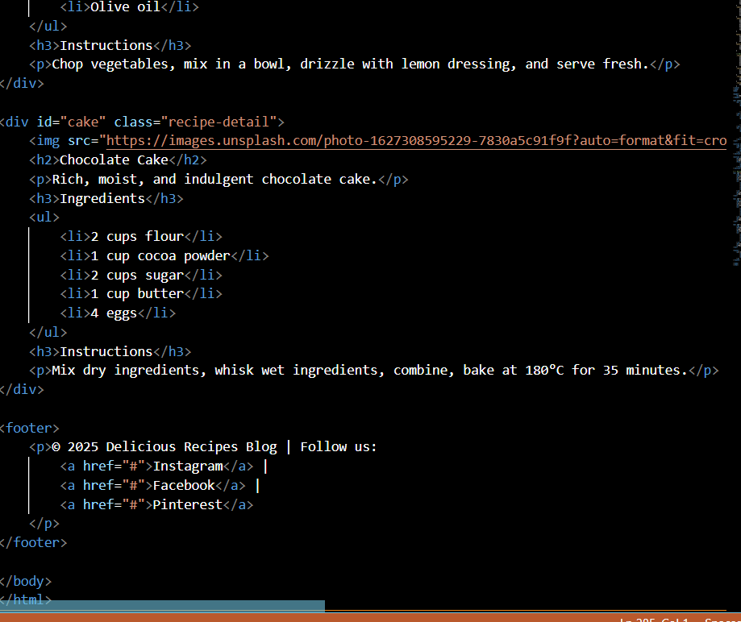

# Screenshots of Final Output

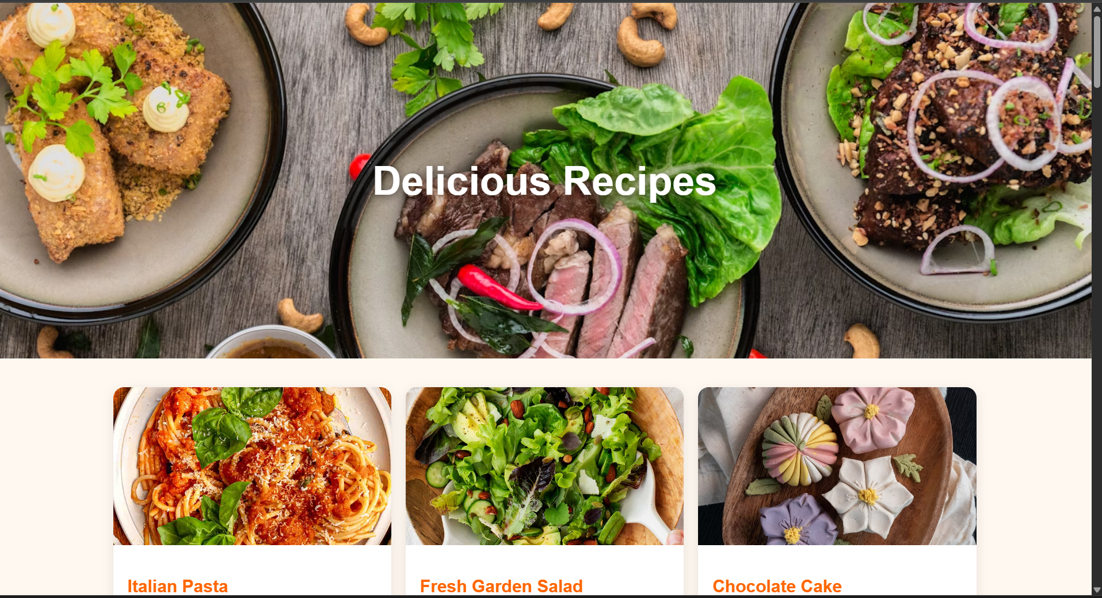

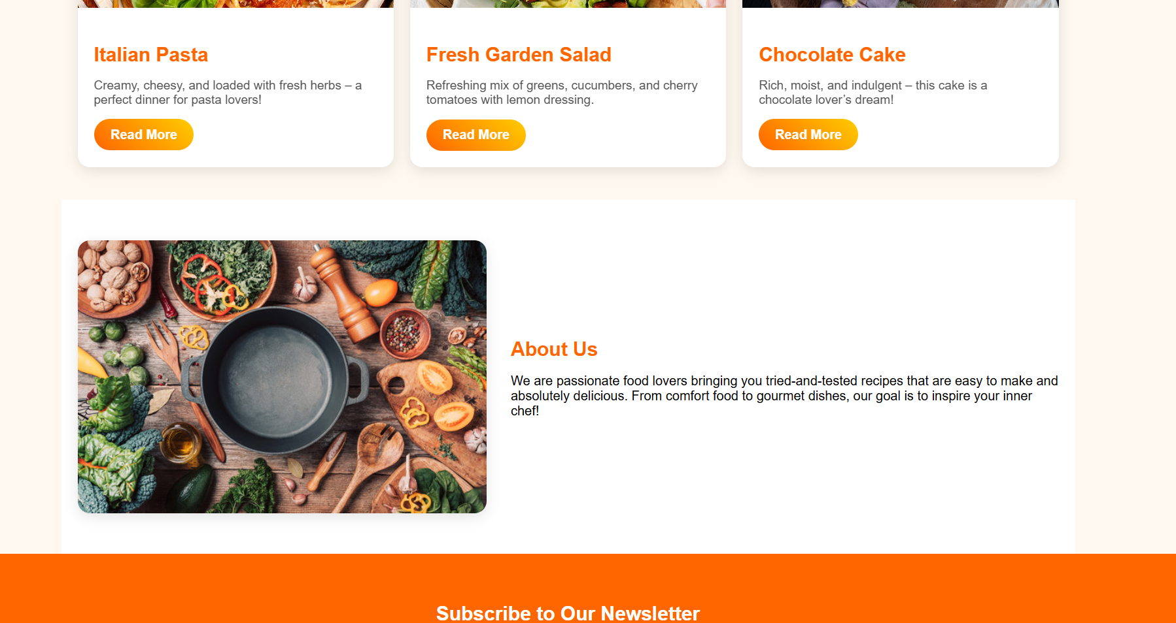

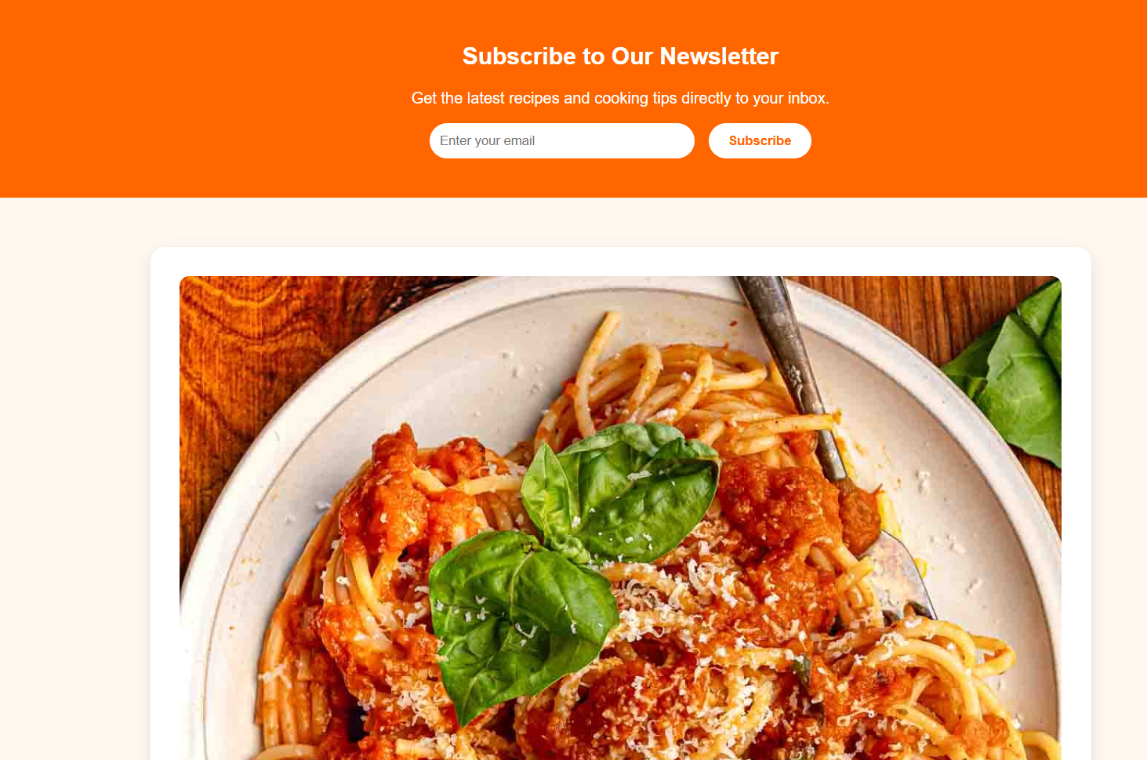

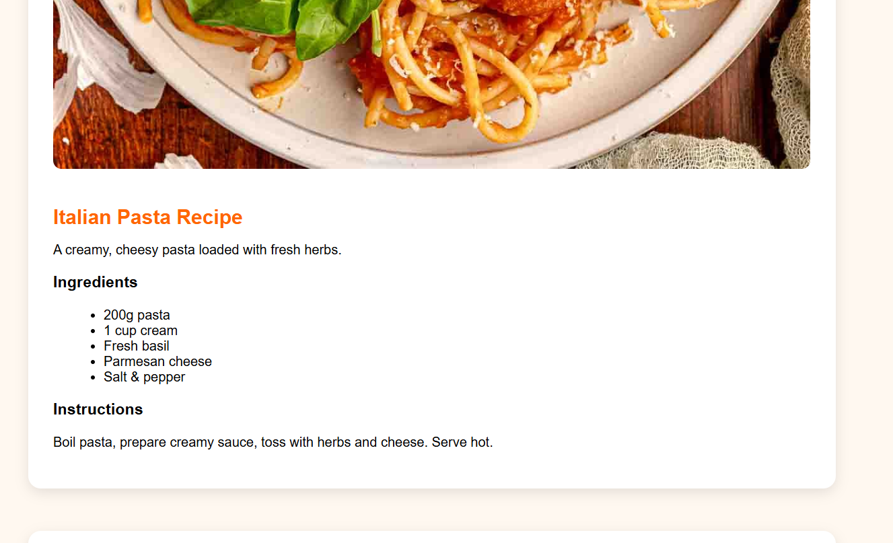

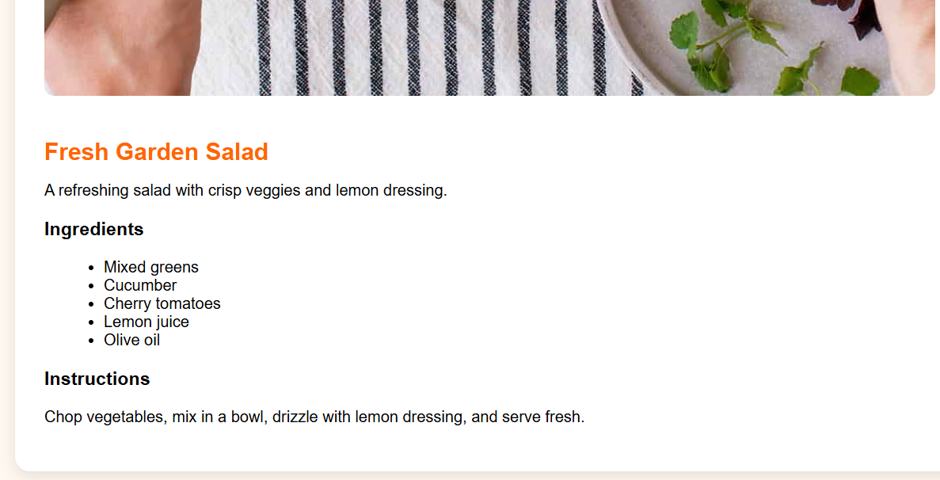

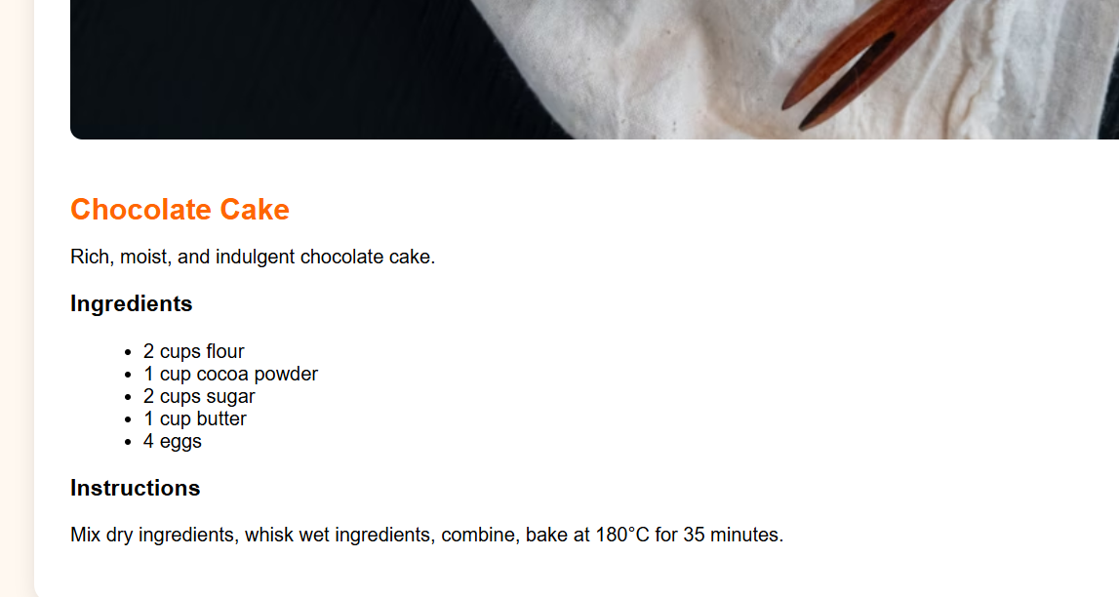

# Conclusion

The Recipe Blog project was an opportunity to practice and refine front-end development skills using only HTML and CSS. The project successfully met its goals of creating a clean, responsive, and user-friendly website. The team gained practical experience in layout design, semantic coding, and accessibility principles. This project definitely helped us strengthen our CSS skills and helped us gain practical insights into the design and the layout of this project.

# References

• L&T LMS : https://learn.lntedutech.com/Landing/MyCourse